



|  |  |  |
| --- | --- | --- |
| **Supervisor** | SIR SHAHRYAR | |
| **Batch** | 2208C2 | |
| **Group** | **A** | |
| **Serial No.** | **Enrollment Number** | **Student Name** |
| 1. | Student1417942 | HUDA |
| 2. | Student1411205 | PAKEEZA |
| 3. | Student1417919 | OWAIS ALAM |
| 4. | Student1411204 | AMMAR IRFAN KOTWAL |

**WEBSITE NAVBAR:**



**ADMIN NAVBAR:**

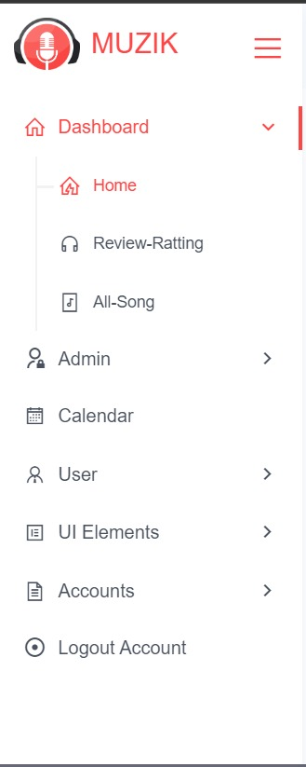

**Carousel:**



**ALBUM LIST:**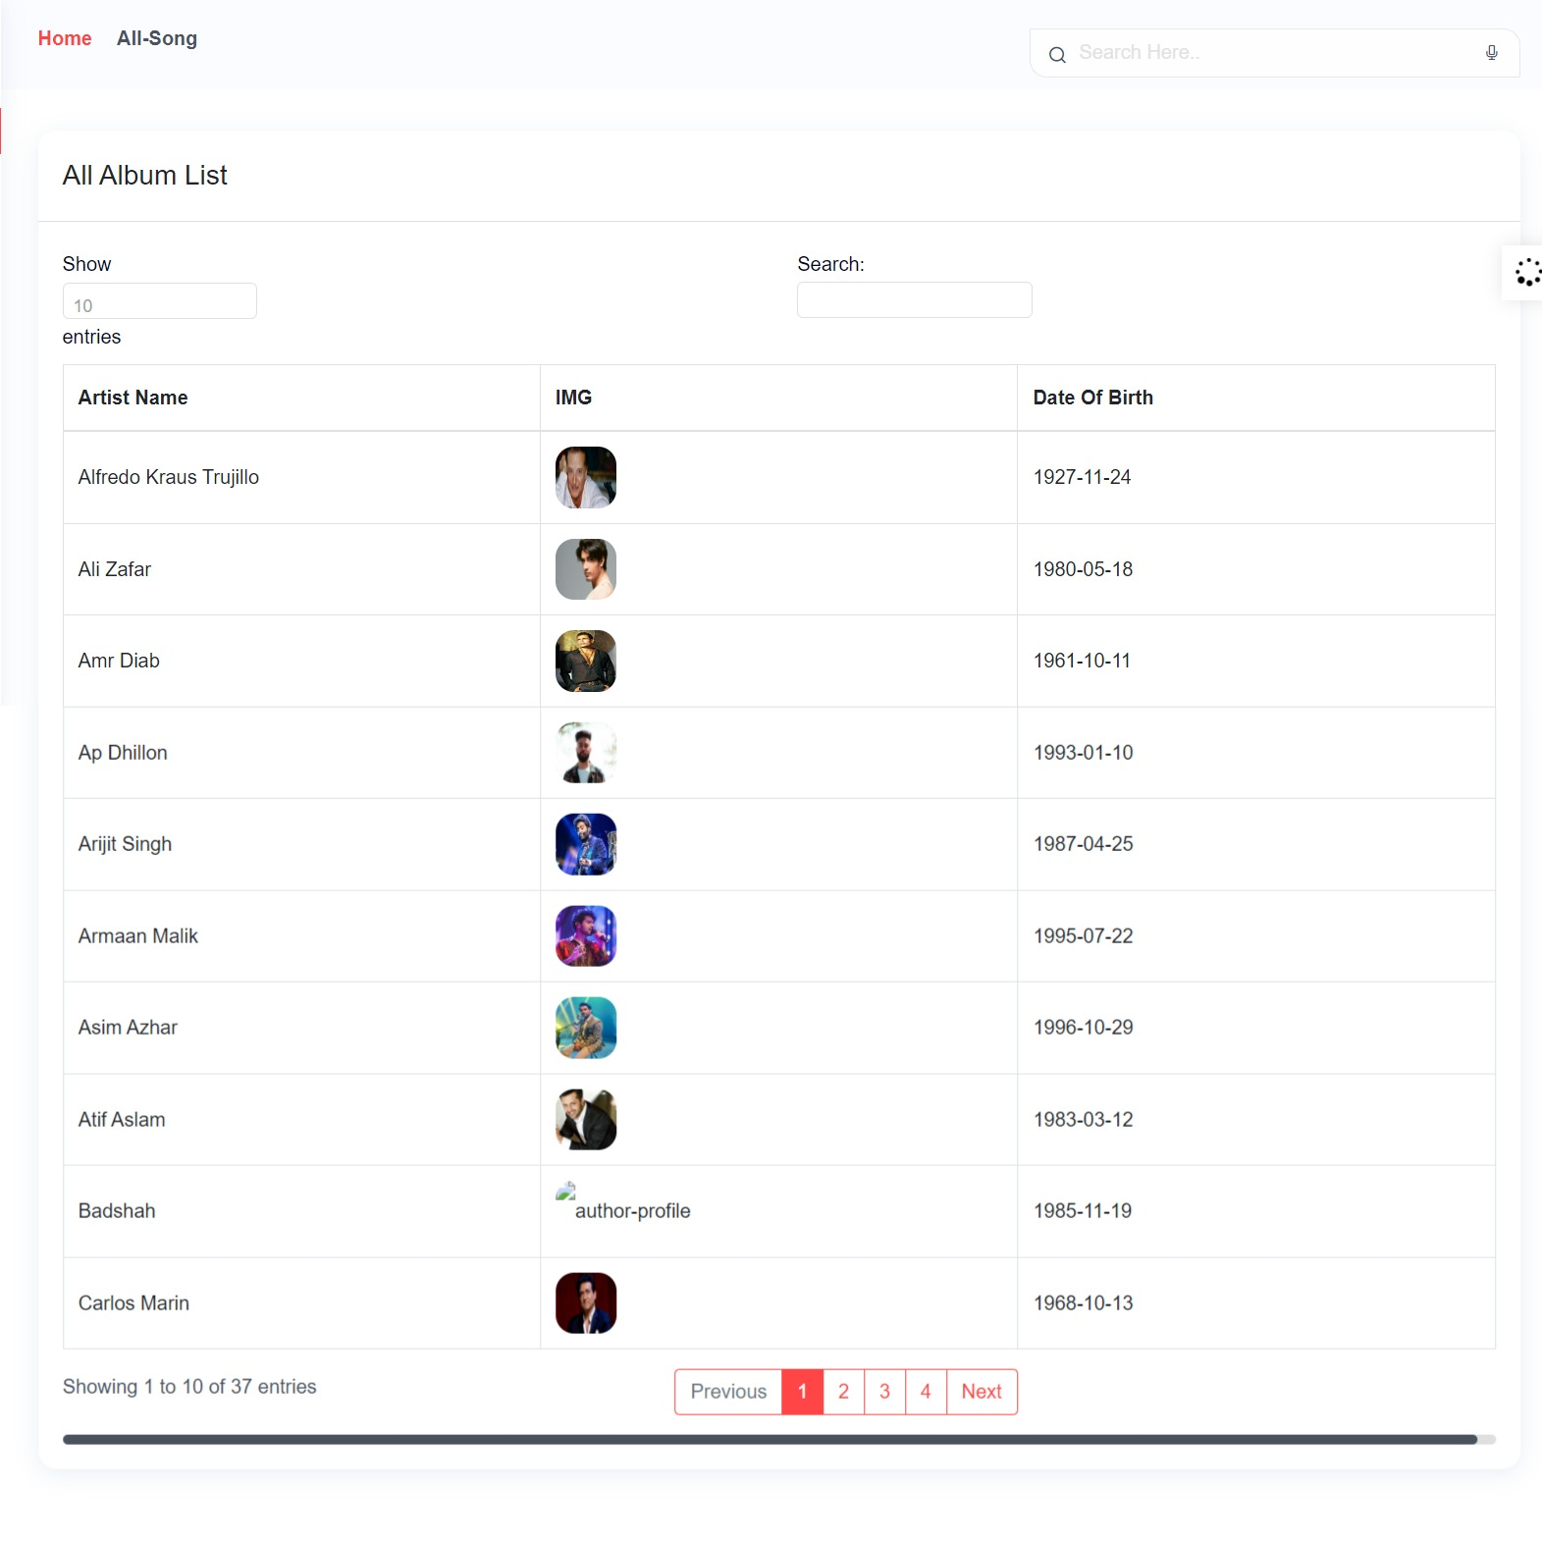

**SINGER LIST:**

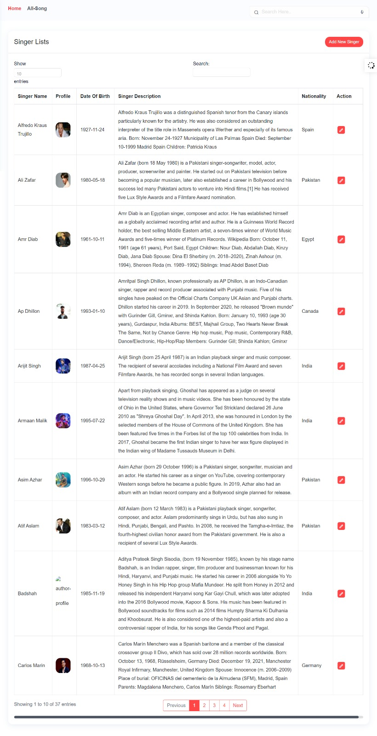

**ADD SINGERS FORM:**

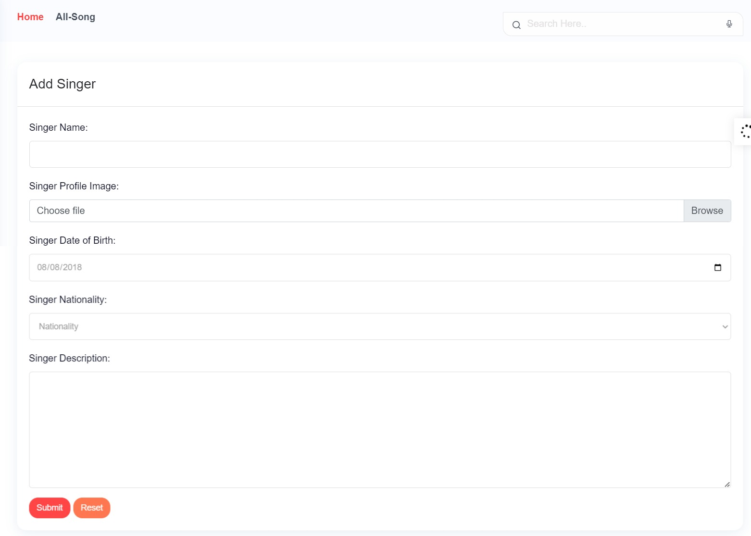

**UPDATE SINGERS:**

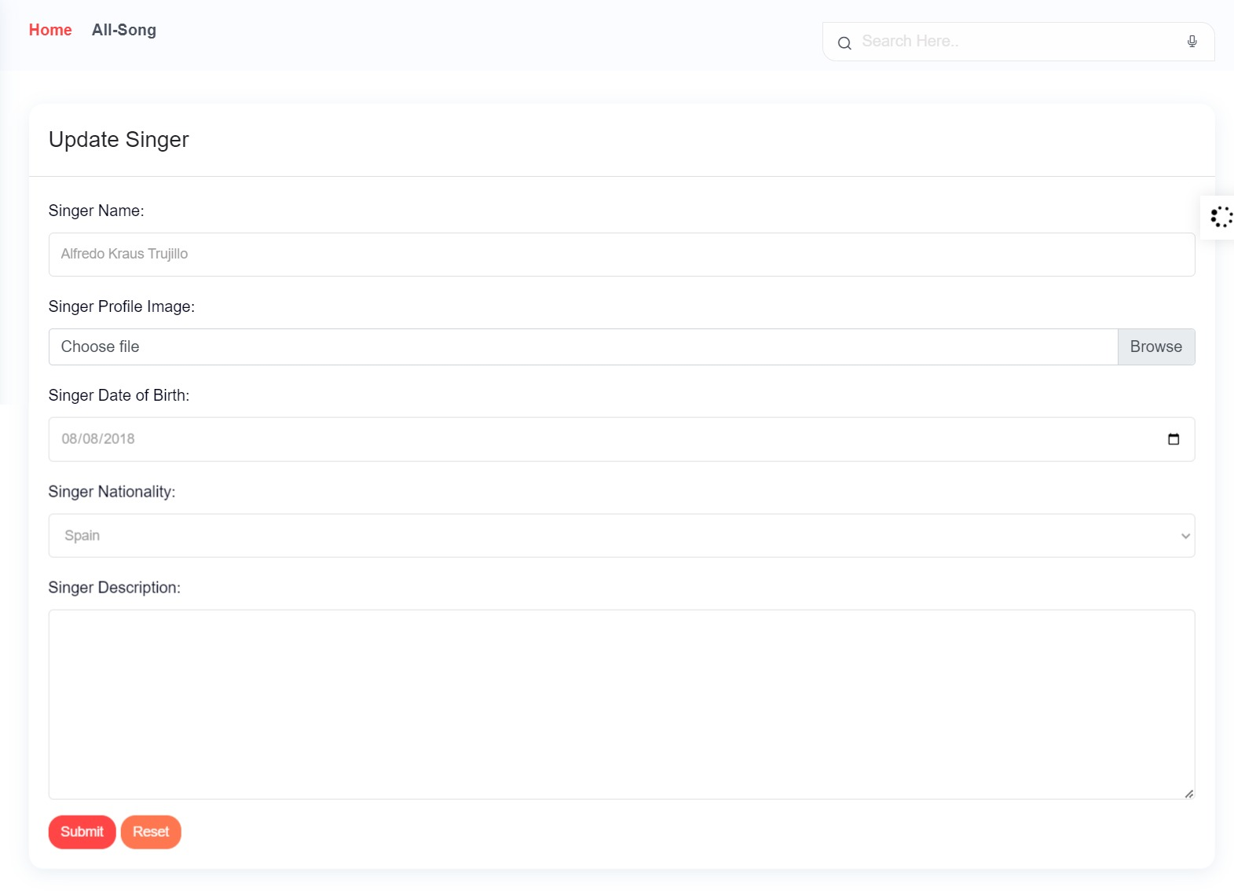

**CODE SNIPPETS:**

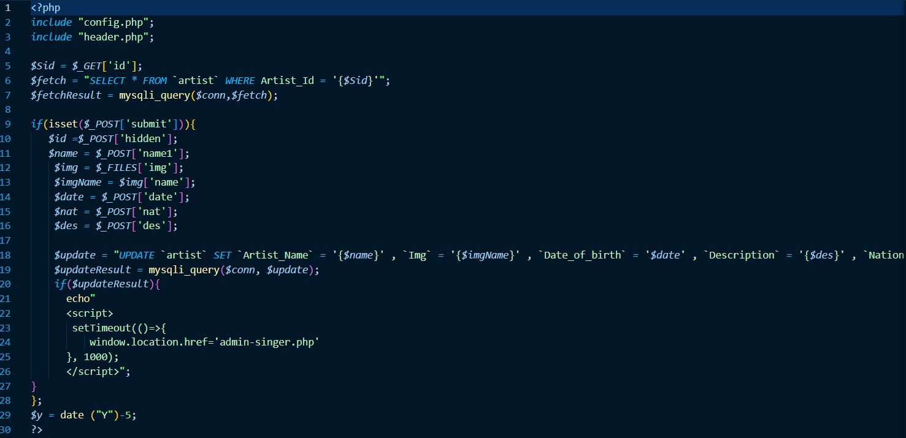

**SONGS LIST:**

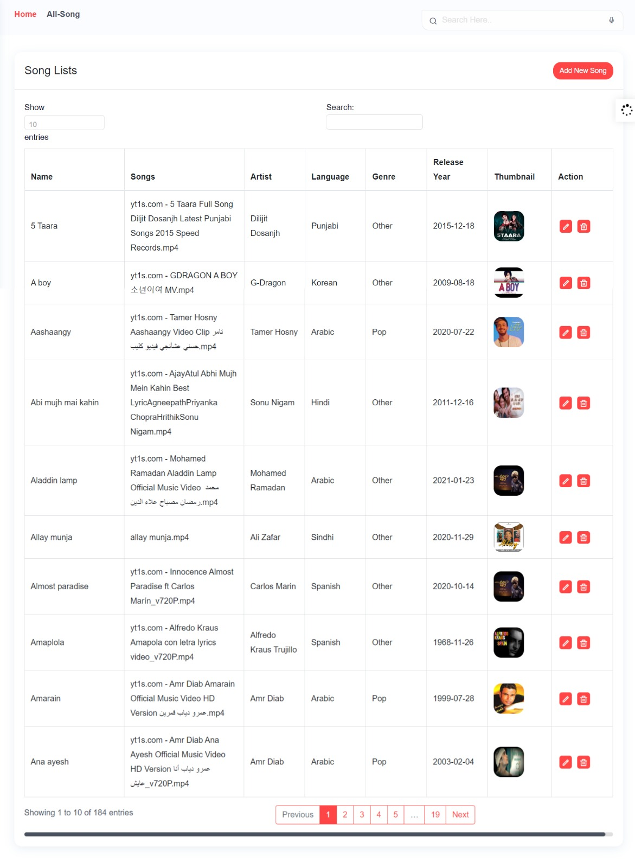

**ADD SONGS FORM:**

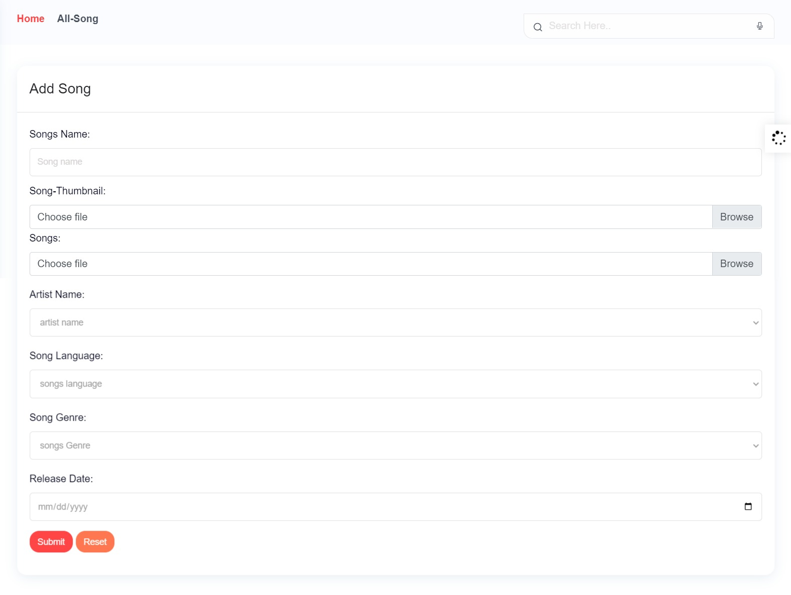

**UPDATE SONGS:**

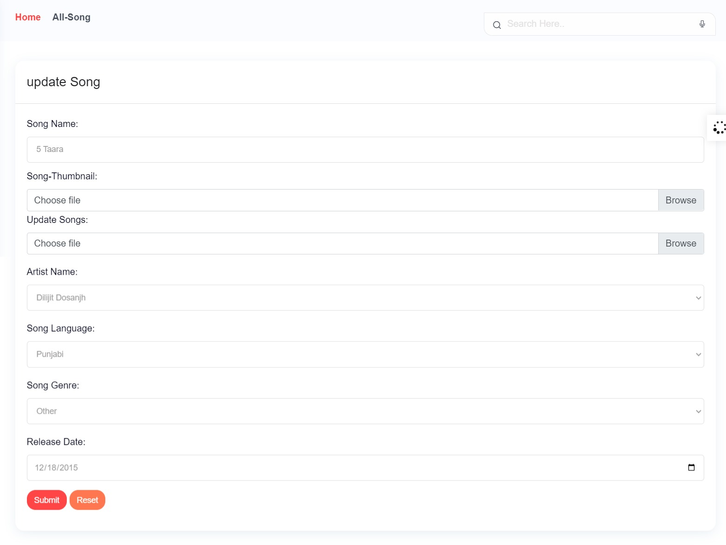

**CODE SNIPPETS:**

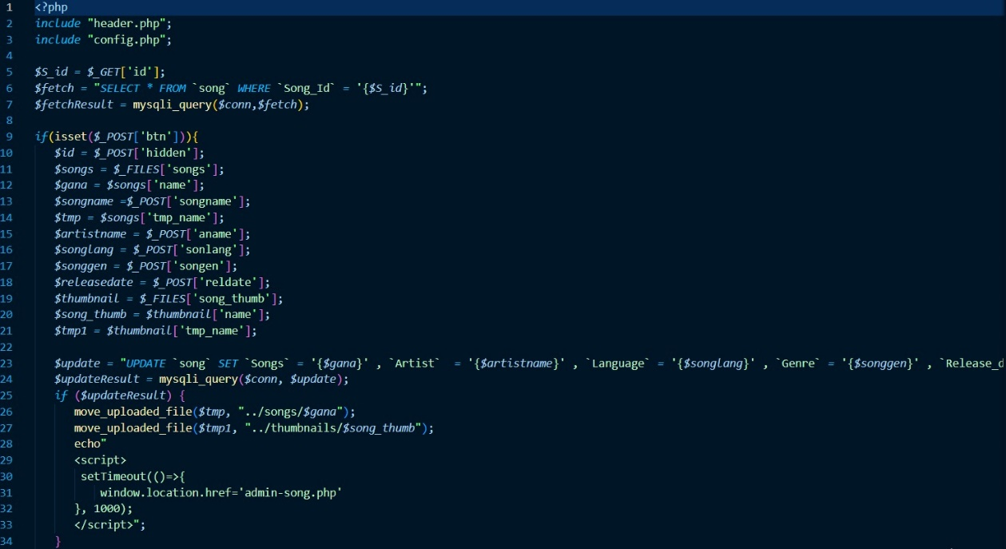

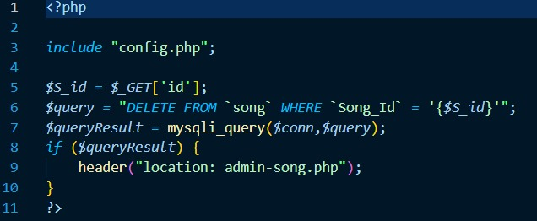

**OST LIST:**

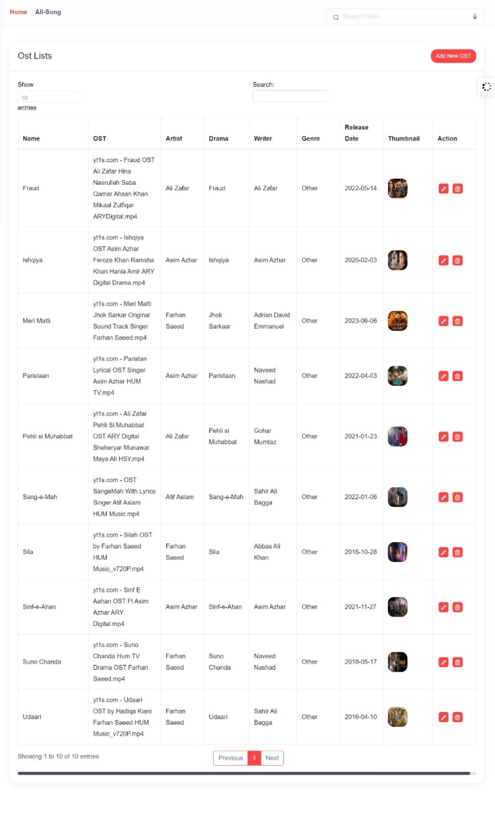

**ADD OST FORM:**

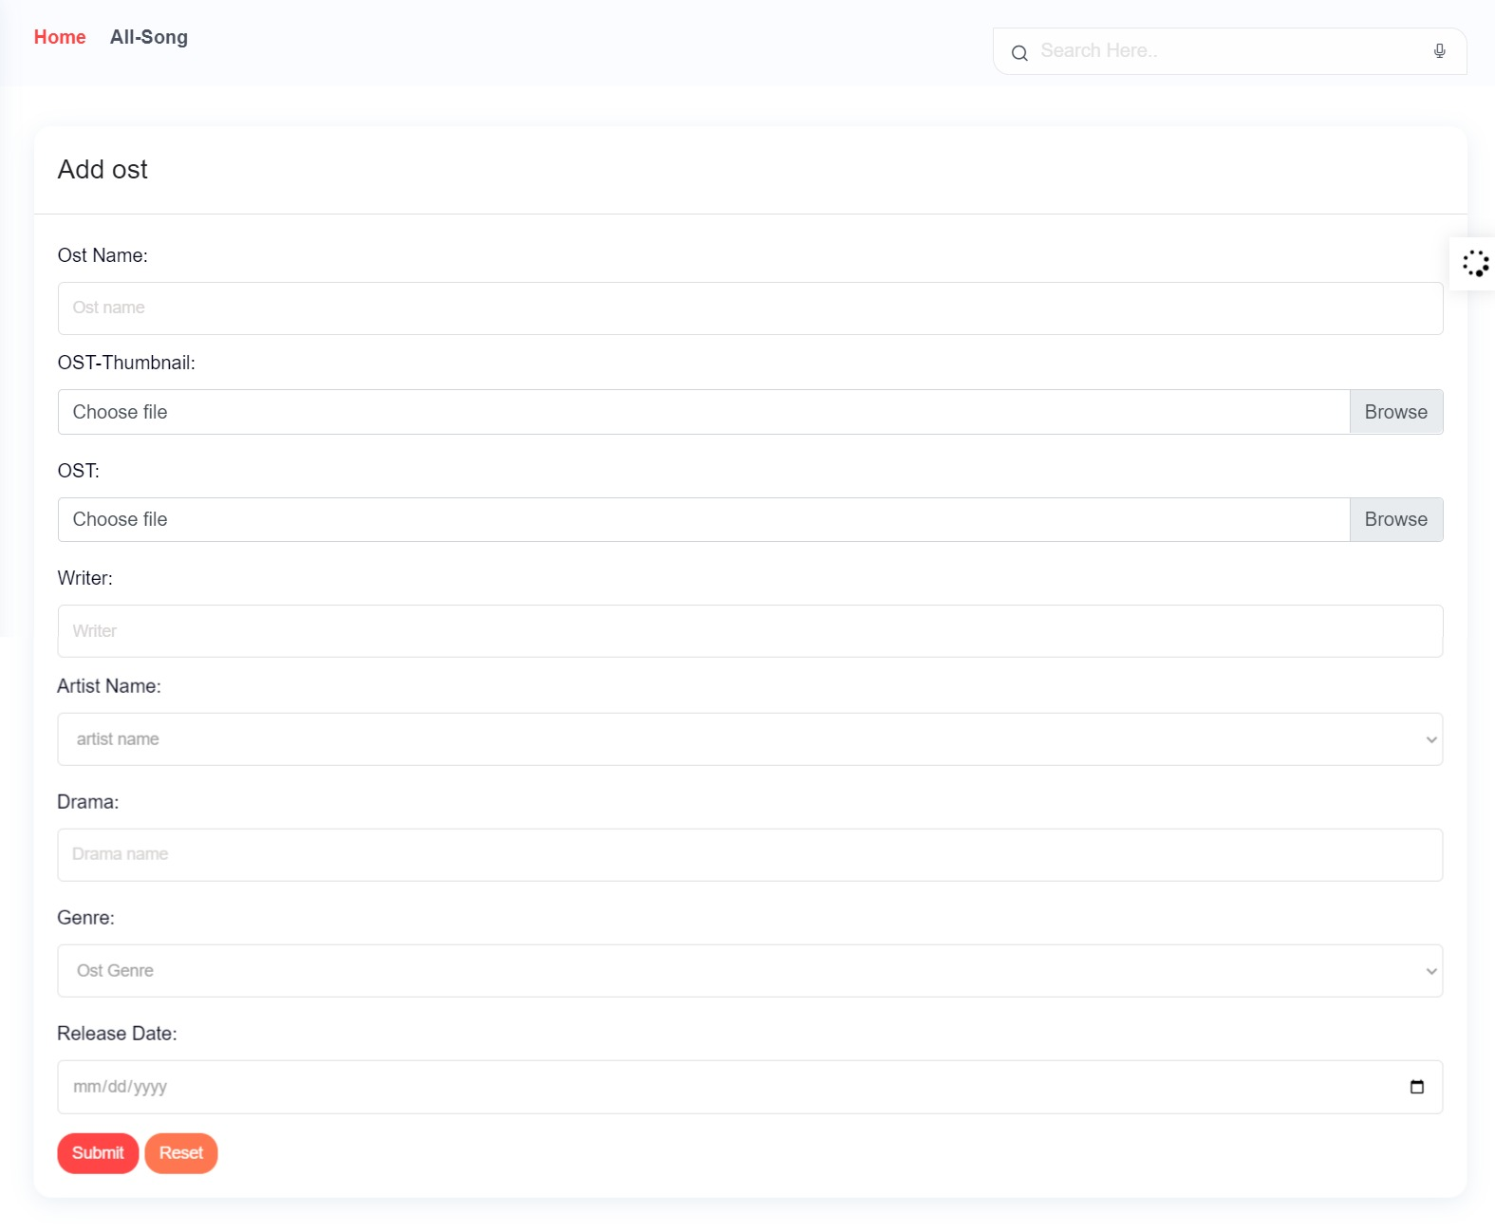

**UPDATE SONGS:**

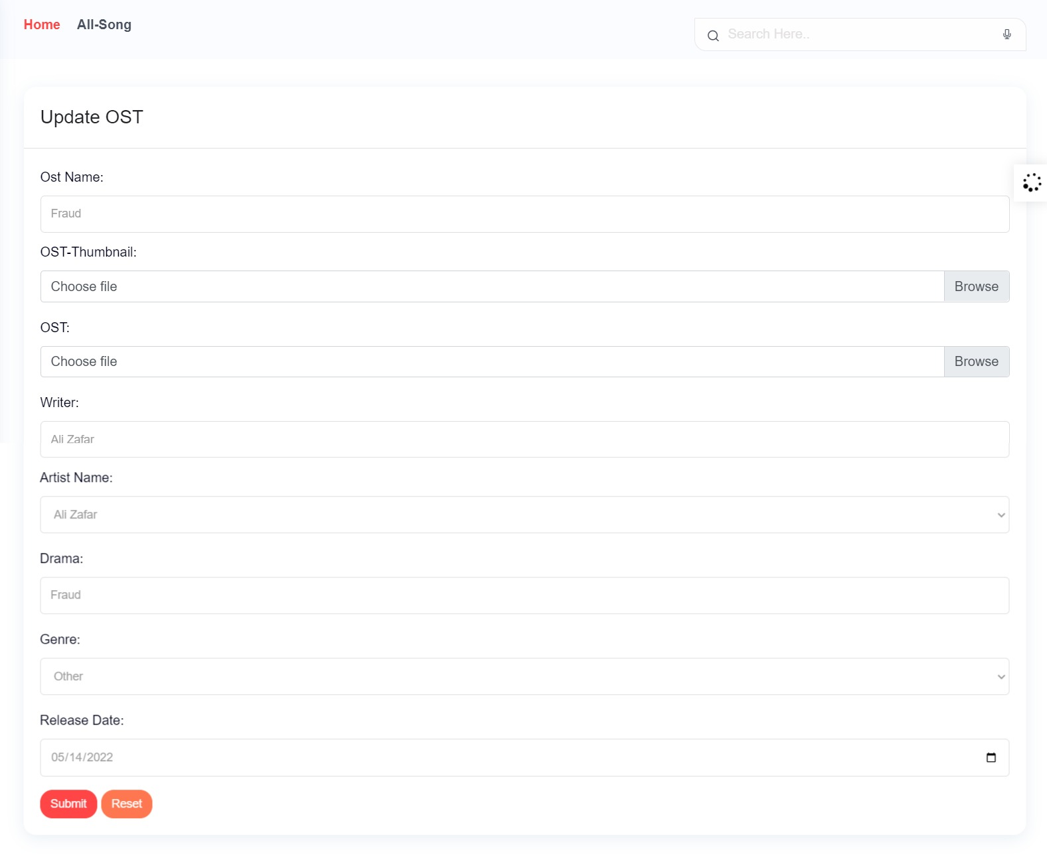

**CODE SNIPPETS:**



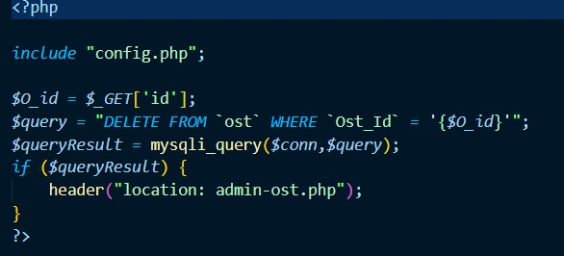

**USER SIGNUP LOGIN FORM:**

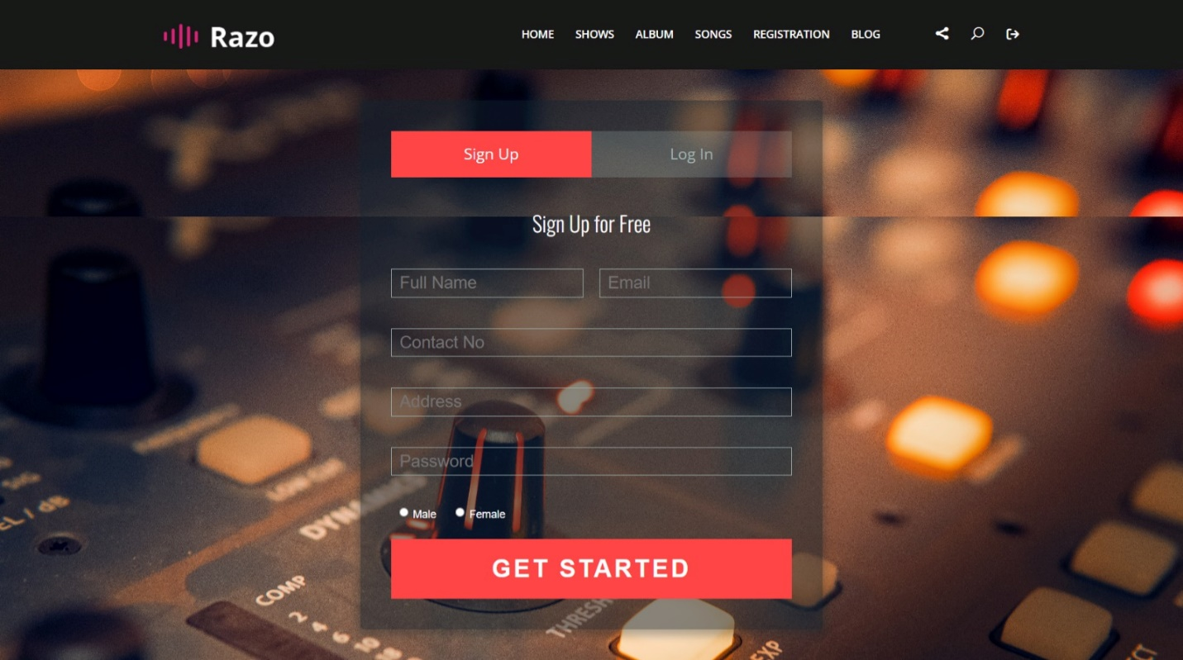

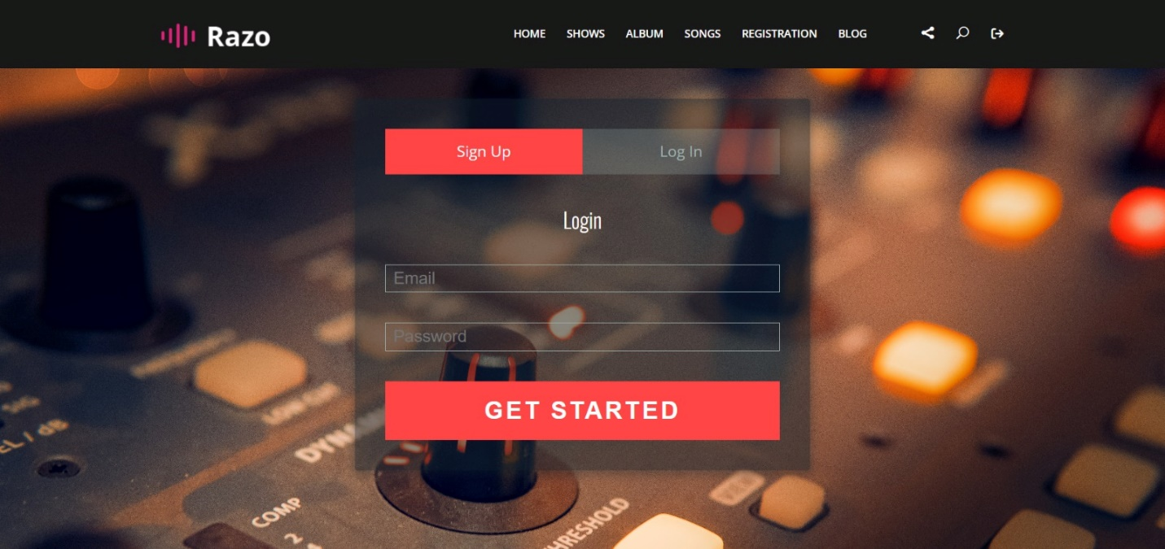

**CODE SNIPPETS:**

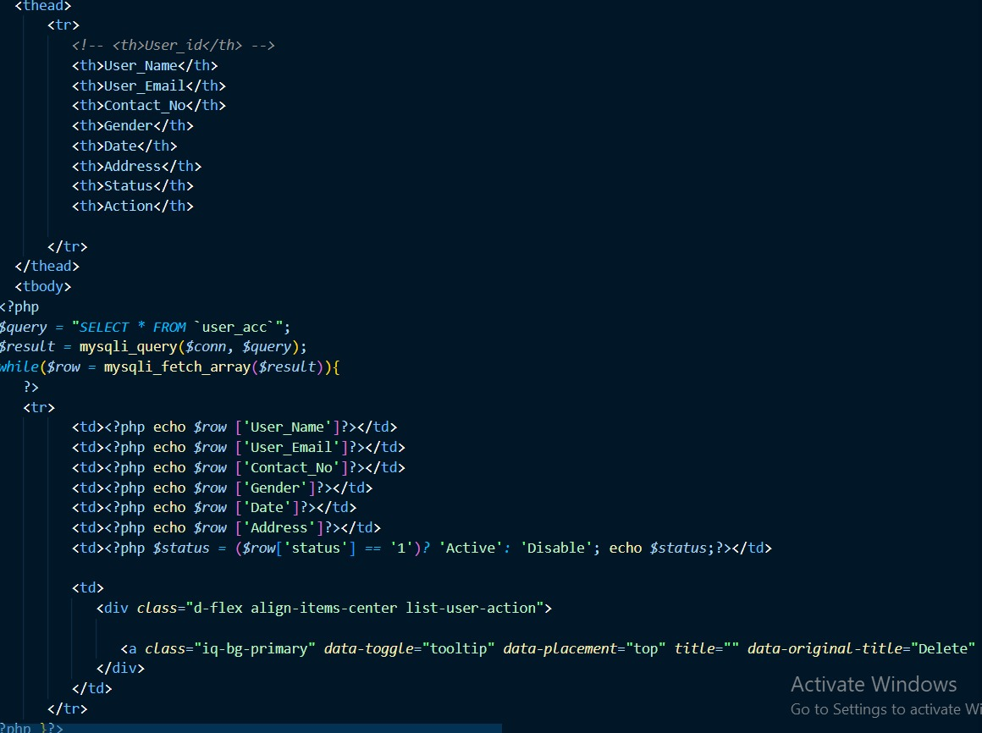

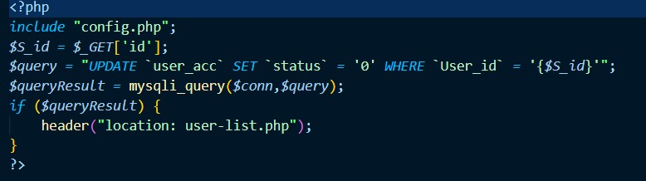

**DASHBOARD:**

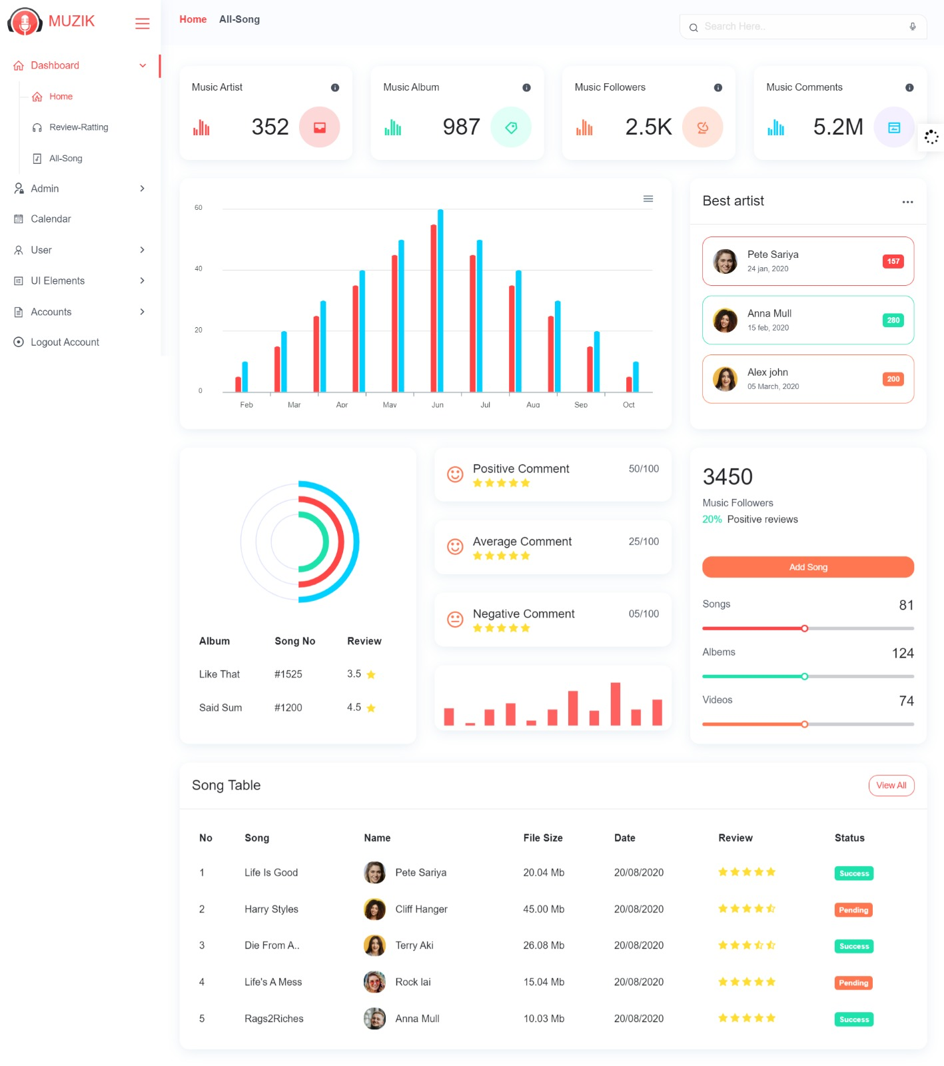

**HOME PAGE:**



**REGISTRATION FORM FOR ADMIN:**

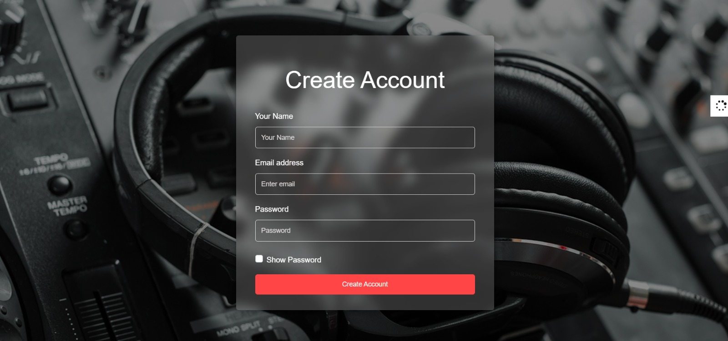

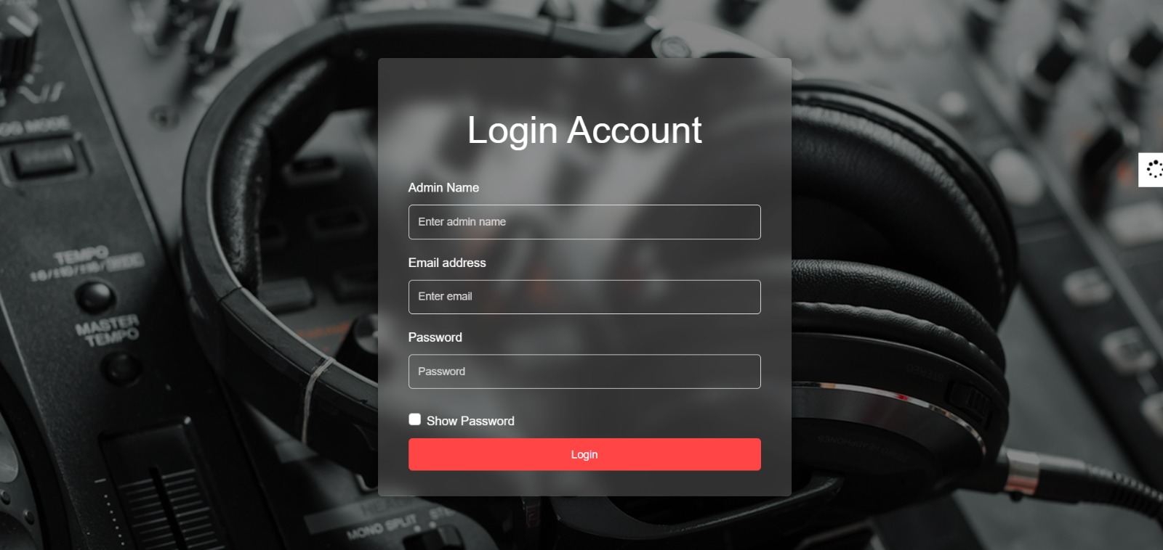

**CODE SNIPPETS:**



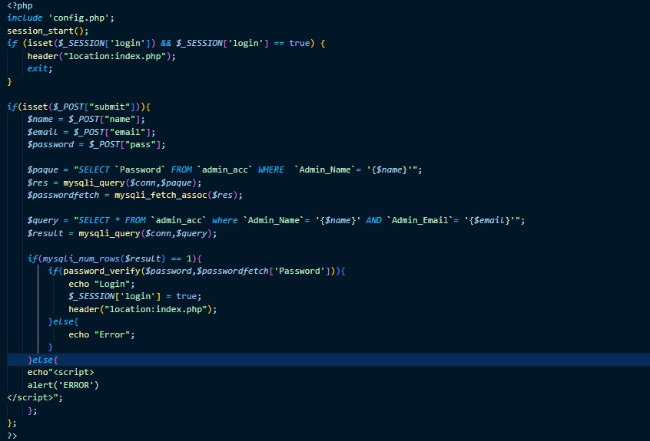

**DATABASE:**

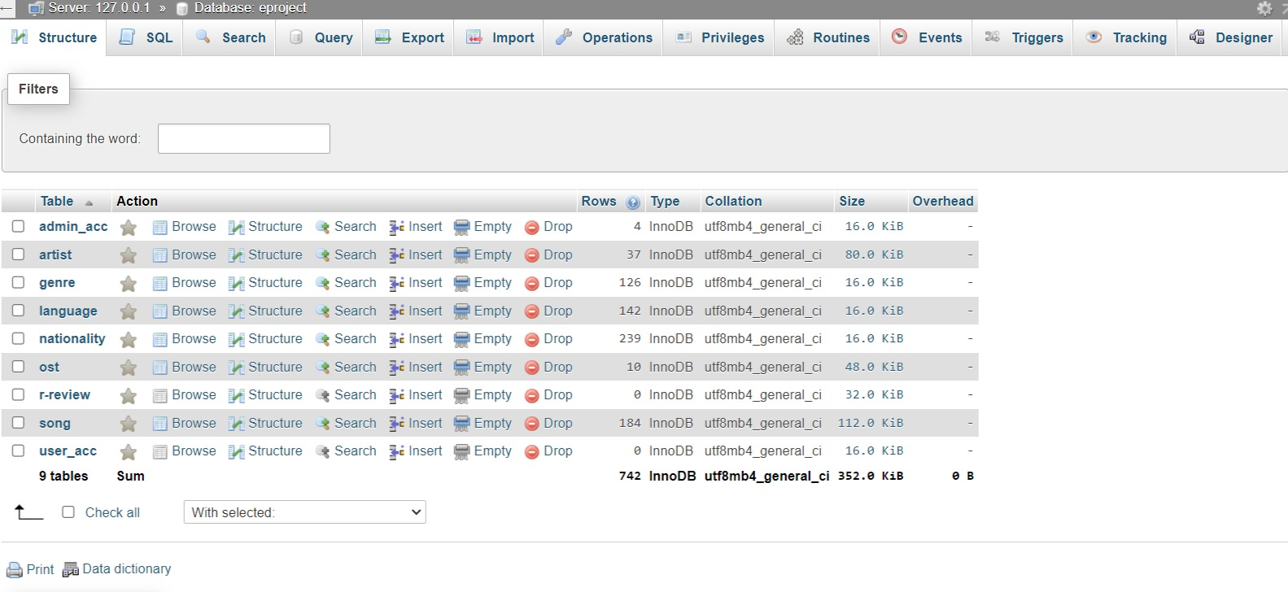

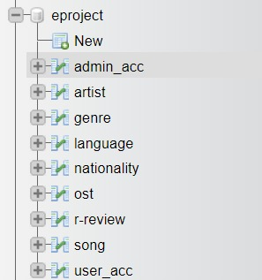

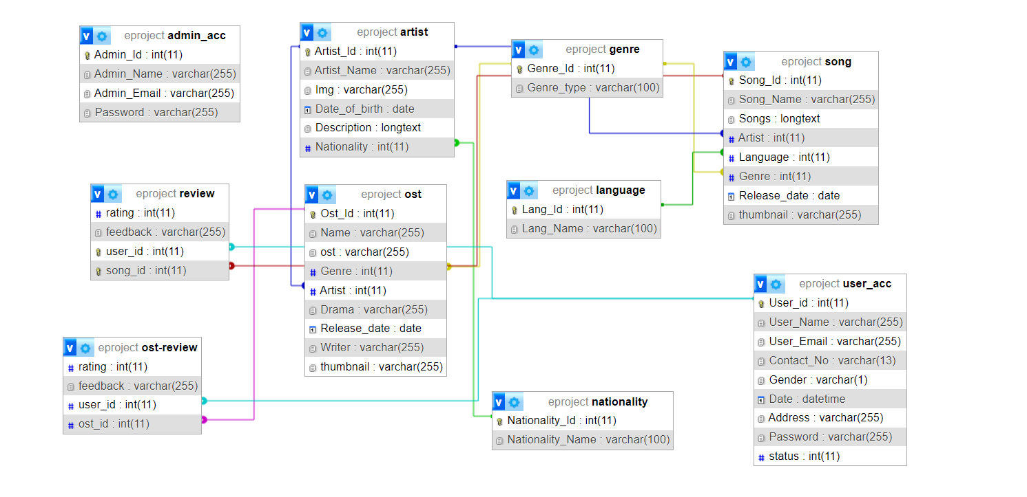**ERD:**

**FOOTER:**

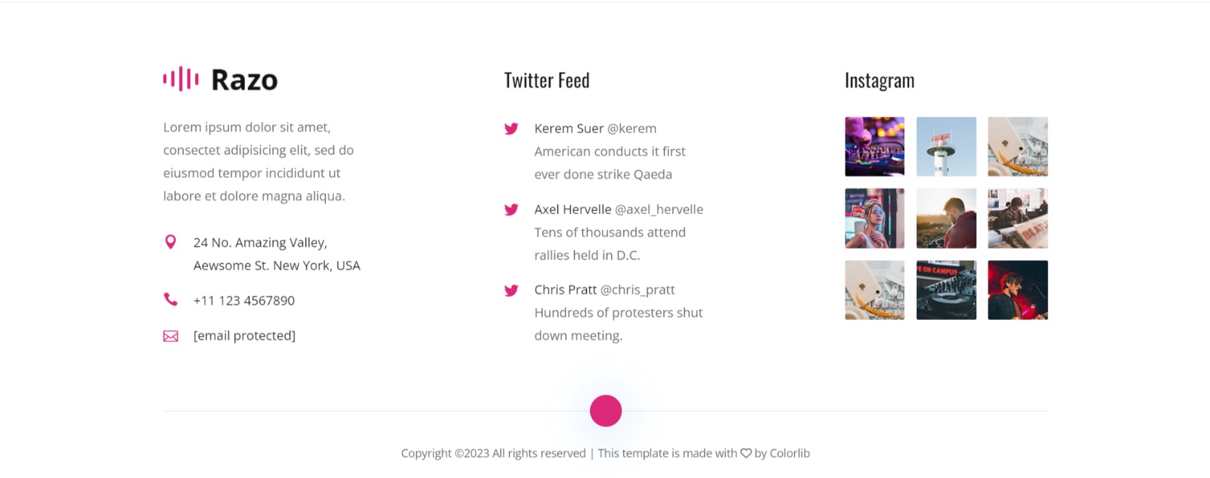

**SUMMARY:**

Incorporating sounds, music, and songs into the backend of a website adds a dynamic and engaging dimension to the user experience. By leveraging various technologies and techniques, a backend system can effectively manage and deliver audio content, enhancing the overall appeal of the website. Here's a summary of the key aspects involved:

1. Audio Content Storage and Retrieval: The backend handles the storage of audio files, which can range from individual songs to entire albums. These files are stored on a server or in a cloud storage service. The backend also manages the retrieval of audio content when requested by users.
2. Metadata Management: Backend systems store and manage metadata associated with audio files, including track titles, artists, genres, release dates, and album covers. This metadata facilitates organized browsing and searching of audio content.
3. Streaming and Playback: The backend implements mechanisms for streaming audio files to users' devices. It handles the necessary encoding and compression, ensuring smooth playback without significant delays. Streaming technology allows users to enjoy music without the need to download the entire file.
4. User Profiles and Playlists: Backend systems enable users to create profiles, which can include personalized playlists, favorite songs, and listening history. These features enhance user engagement by tailoring the music experience to individual preferences.

In conclusion, sounds, music, and songs are powerful elements that can transform a website's user experience. The backend plays a crucial role in managing audio content, from storage and retrieval to streaming and personalization. By effectively integrating these features, a backend system can create an immersive and enjoyable musical journey for users, fostering engagement and loyalty.